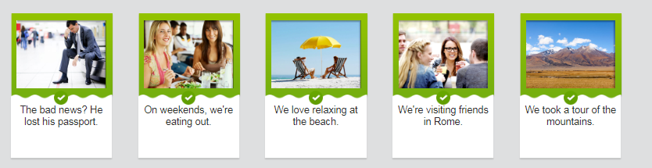

跟读
We're saving money because we're not eating out.
我们在省钱，因为我们没在外面吃饭。
I hope this vacation lasts forever.
我希望这段假期永远都不要结束。
Lauren lost her wallet.
Lauren 丢了钱包。
We'll try to take a tour of Tivoli Gardens.
我们打算去参观帝沃力花园。
I'll probably relax with my girlfriend.
我很可能会和女友一起轻松轻松。
We want to stay in Budapest.
我们想呆在布达佩斯。

